**26.** **JUNIT TESTING TO CHECK WHETHER THE GIVEN STRING IS PRINTED OR NOT**

**M.GEETHA SRI**

**192110718**

**AIM :**

To Use Junit Testing Check whether the given string is printed or not.

**PROGRAM** :

**package** sse;

**public** **class** junit1 {

**public** **static** **void** main(String[] args) {

// **TODO** Auto-generated method stub

System.***out***.println("hai");

}

}

**OUTPUT:**

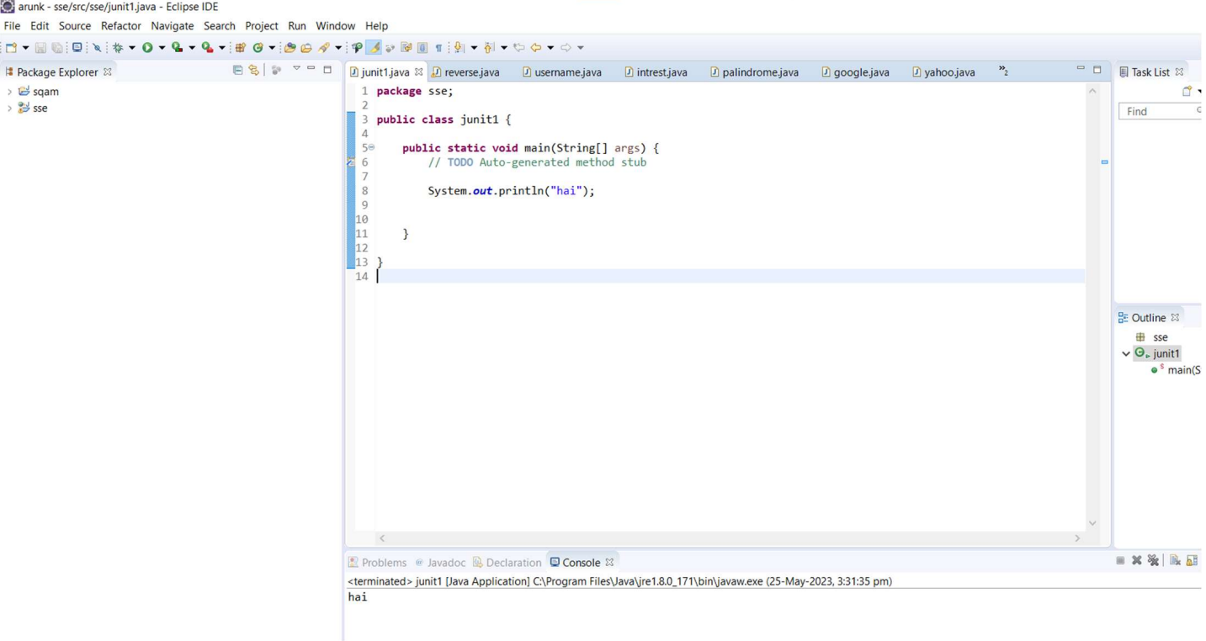

**RESULT:**

Hence the Junit Testing to Check whether the given string is printed or not is executed successfully.